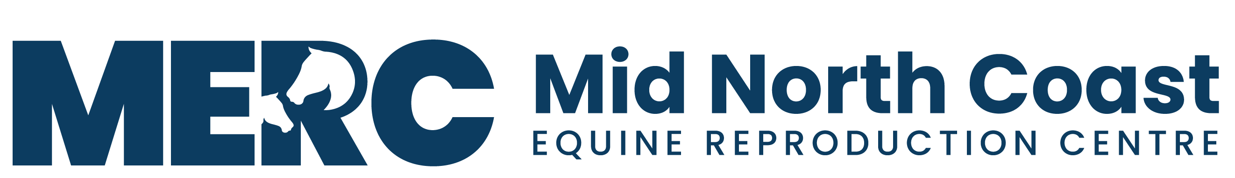
ABN - 76 626 632 836
Phone - Andrew 0429 329 097 - Sheridan 0434 399 358- Karen 0427 627 391
Email – andrew@mvvs.net.au - - - Web - www.mercrepro.net.au
Postal Adress - PO Box 3156 West Kempsey NSW 2440
Property Location – 104 South West Rocks Road Hampden Hall NSW 2440

.
MERC FEES LIST

Item Name Price (Inc GST)

AGISTMENT - MARE DAILY RATE $25.00
AGISTMENT - MARE DAILY OWN PEN RATE $40.00
AGISTMENT - STALLION DAILY RATE $40.00
AGISTMENT - STALLION DAILY RATE - OWN FEED $30.00

DRY SHIPPER - CHARGE DRY SHIPPER $150.00
DRY SHIPPER - HIRE $110.00

EMBRYO TRANSFER - BREED DONOR $800.00
EMBRYO TRANSFER - FLUSH DONOR $660.00
EMBRYO TRANSFER - TRANSFER TO RECIP $500.00
EMBRYO TRANSFER - CRYOPRESERVE EMBRYO $440.00
EMBRYO TRANSFER - RECIPIENT LEASE $3,740.00
EMBRYO TRANSFER RECIP PREP $550.00

MARE BREEDING - AI PROGRAM (TO CARRY OR ET) $800.00
MARE BREEDING - NATURAL SERVICE PROGRAM (TO CARRY) $660.00
MARE BREEDING - NATURAL SERVICE PROGRAM (ET) $660.00

SEMEN COLLECTION & PREPARATION $395.00
SEMEN COLLECTION TRAINING OR CLEAN OUT $265.00
SEMEN COLLECTION & FREEZE (NOT INCLUDING EXTENDER) $450.00

ULTRASOUND $80.00

UTERINE CURRETTE PROGRAM $400.00

