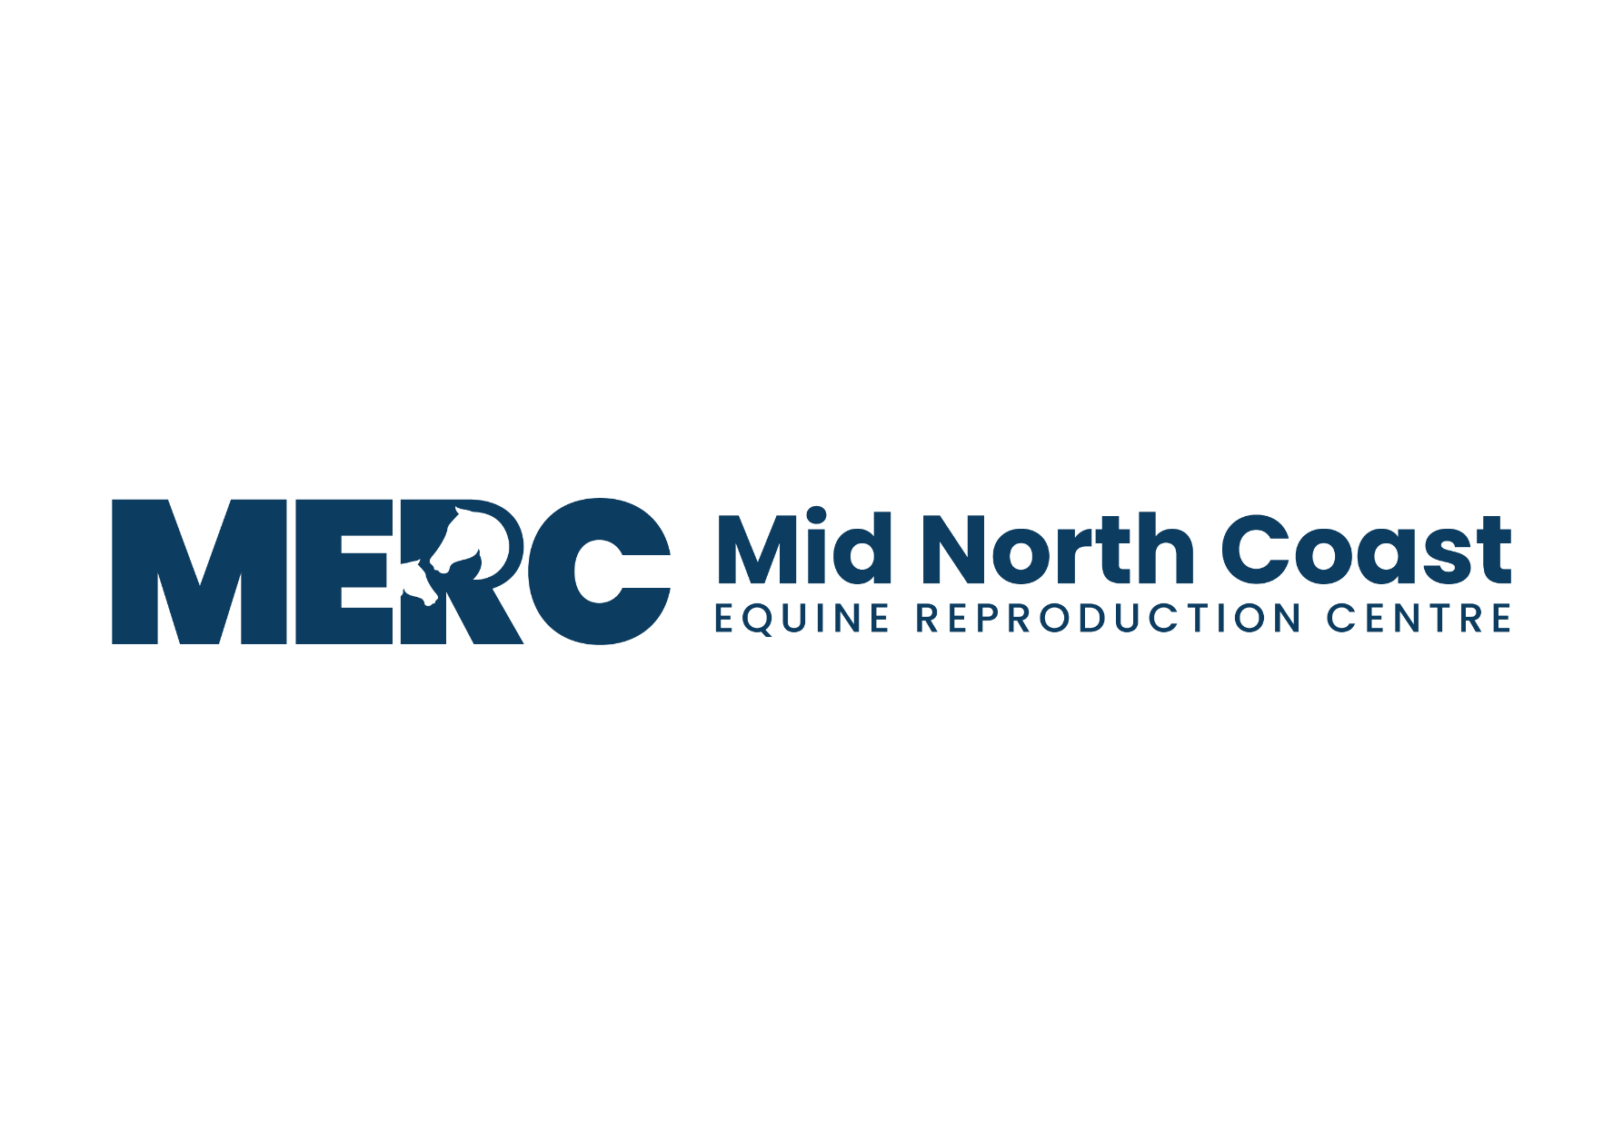

**ABN - 76 626 632 836**

**Phone - Andrew 0429 329 097 - Sheridan 0434 399 358- Karen 0427 627 391**

**Email –** [**andrew@mvvs.net.au**](mailto:andrew@mvvs.net.au) **- - - Web -** [**www.mercrepro.net.au**](http://www.mercrepro.net.au)

**Postal Adress - PO Box 3156 West Kempsey NSW 2440**

**Property Location – 104 South West Rocks Road Hampden Hall NSW 2440**

**MERC - MARE ADMISSION CHECKLIST**

Please take time to read the admission information below. Please don’t hesitate to contact Andrew for any further information or if you have any requirements specific to your mare.

This season our mare breeding period is from **8th October to 17th December.**

***Prior to Arrival***

1. Please remove hind shoes from mares before arrival. For the safety of other mares, only mares without hind shoes are admitted.
2. Finalise financial & contract arrangements with the stallion owners & the stallion collection vets and have budgeted to pay the MERC fees.
3. Pay MERC Deposit.
   1. $1000 per breeding program
   2. $5000 per embryo program

Payment can be made by either.

* Providing credit card details (email or text them through to me) or
* Cash or
* Direct Debit – use your surname as a reference.
  + AC:         MERC
  + BSB:       062 592
  + Ac:         1100 1153

1. Hendra vaccination is not required but we do recommend that all horses be vaccinated. Unvaccinated horses can be admitted but in the unlikely event of a Hendra case at this or a neighbouring property they will be quarantined and agistment will be at the mare owner’s expense.
2. Arrange a time for admission with me by phone, text or email.

***Arrival***

1. Please try to arrive as arranged. We try to do all admissions and pick ups at certain times of the day so as not to interrupt workflow.
2. Entry to MERC is by appointment only. We need to satisfy biosecurity standards as well as privacy for our clients and their animals so at other times the front gates are closed.
3. MERC is on the eastern side of Kempsey approximately 1km from the town limits at 104 South West Rocks Road Hampden Hall. If you need any help, please let me know.
4. Once at the top of the drive take the first right. There trucks can back in, floats drive in and then back into the unloading area next to the dog kennels leaving room for others to use the roundabout while you unload. There are unloading areas for trucks, mares and foals and mares on floats. Please take time to back into these leaving as much room as possible for others. Please keep any dogs in your vehicle.
5. Please have any documentation ready to be added to your mare’s file on admission.

***After Admission***

1. Your mare will be fed and given time to settle in her own feed pen. After all the new mares have had time to settle the mares are let out together into their paddock. Dry mares run together, and mares and foals are in a separate paddock. The embryo recipient herds run in separate paddocks. All paddocks access the yards and mares are fed in individual pens at least once a day.
2. The paddocks are electrified with a standoff and have 4 plain wires with a white sight wire on the top. While we have not had a major injury, it is always possible when mares run together so you need to be comfortable with the environment for your mare. Treatment for any injuries will be at the mare owner’s expense.
3. Any overly aggressive mares or mares that won’t settle in the facility will be sent home and will need to be transported in each morning. There are also isolation pens that can be used but agistment in those is more expensive.
4. During your mare’s cycle, all possible resources will be used to achieve successful outcomes. Extra procedures will be taken if indicated and will be additional to basic invoiced charges. MERC aims for the best possible chance of successful pregnancy and is committed to using the best possible techniques to achieve this aim.
5. We do not allow social visits to mares at MERC. In the interest of biosecurity and minimising workflow disruptions in an extremely busy time we minimise human traffic at this time of year.

***Breeding programs***

1. Updates on your mare. During your mare’s stay at MERC and particularly when she is in season Andrew will communicate directly with the mare owner so as everyone knows how she is progressing. As it is such a busy time this is usually done by text message. Mare owners are also welcome to contact Andrew directly to discuss anything they are unsure about as the cycle progresses.
2. Freight. Every effort will be made to ensure that semen is ordered and freighted to arrive on time and in good condition. Unfortunately, MERC cannot be responsible for freight and the condition which insemination doses arrive. In the case of unsatisfactory quality of insemination due to freight or stud complications all costs associated are the responsibility of the mare owner.
3. MERC Fees – These fees are a basic guideline to services charged at MERC.
   * $800 per breed cycle (includes all scans, mare prep, ovulation induction, AI, post ovulation treatments, 16- & 42-day pregnancy scans)
   * $25 per day Agistment for all mares in paddocks. This includes ultrasound examinations as required.
   * $40 Agistment for individual pens when available
   * Embryo Programs
     + - $800 per breed cycle
       - $660 per flush
       - $550 per transfer
       - $3740 per recip lease from day 35 to weaning.
       - $550 per own recip preparation program

***Payment***

1. Mare owners are expected to budget so that they have sufficient available funds to pay in full for all services as they are invoiced.
2. MERC does not do payment plans or credit.
3. Payment is due in full on receipt of invoices from MERC. Payment is not in any way related to breeding outcomes.
4. Invoices will be issued weekly - monthly and before your mare is ready to be collected. Please ensure payment is made promptly,
5. Credit card payments can be made at MERC and carry the standard small surcharge.

Direct Debit payments should be made to MID NORTH COAST EQUINE REPRODUCTION CENTRE

BSB: 062 592 & AC: 1100 1153 - REFERENCE: *Your surname*